**COMSATS UNIVERSITY ISLAMABAD**



**SUBMITTED BY:**

**MARYAM MUKHTAR**

**REGISTRATION NO:**

**FA24-BBA-123**

**SUBMITTED TO:**

**PROF. MUFEEZA MANZOOR**

**ASSIGNMENT TITLE:**

**LAB WORK**

**DEADLINE DATE:**

**OCTOBER 19th, 2025**

**PART 1: LISTS**

**PROGRAM CODE:**

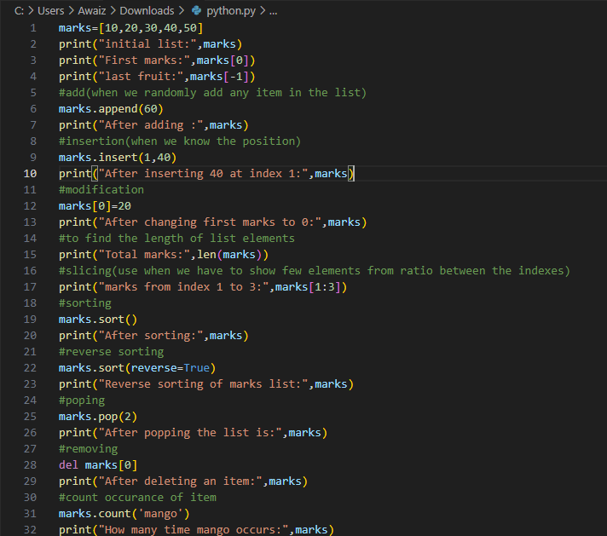

**OUTPUT :**

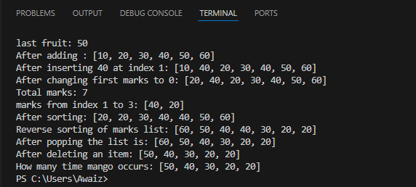

**PART 2: TUPLES**

**PROGRAM CODE:**

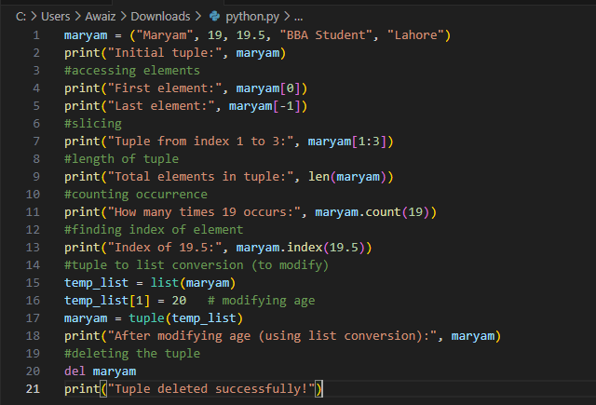

**OUTPUT :**

